Practical : 16

## Aim: Write sample application to connect to database (connection object), Fetching and inserting data from database (command object) and using Data Reader.

First.aspx

<%@ Page Language="vb" AutoEventWireup="false" CodeBehind="First.aspx.vb" Inherits="Practical_16.First" %>

<!DOCTYPE html>

<html xmlns="http://www.w3.org/1999/xhtml">

<head runat="server">

<title></title>

</head>

<body>

<form id="form1" runat="server">

<div>

<asp:Button ID="btnFetch" runat="server" Text="Fetch Data" />

<asp:Button ID="btnInsert" runat="server" Text="Insert Random Data" />

<br />

<asp:DropDownList ID="drpFetch" runat="server" AutoPostBack="true" />

</div>

</form>

</body>

</html>

First.aspx.vb

Public Class First

Inherits System.Web.UI.Page

Protected Sub Page_Load(ByVal sender As Object, ByVal e As System.EventArgs) Handles Me.Load

End Sub

Protected Sub btnFetch_Click(sender As Object, e As EventArgs) Handles btnFetch.Click

Dim con As New SqlClient.SqlConnection("Data Source=(LocalDB)\MSSQLLocalDB;AttachDbFilename=C:\Users\ISHAN\Desktop\Databases\Students.mdf;Integrated Security=True;Connect Timeout=30")

Dim cmd As New SqlClient.SqlCommand("select Area from students", con)

Dim dr As SqlClient.SqlDataReader

con.Open()

dr = cmd.ExecuteReader()

While dr.Read()

drpFetch.Items.Add(dr.Item(0))

'Response.Write(dr("ID") & dr(1) & dr(2) & "</br>")

End While

con.Close()

End Sub

Protected Sub btnInsert_Click(sender As Object, e As EventArgs) Handles btnInsert.Click

Dim fname As String

Dim lname As String

Dim Area As String

Dim Position As String

fname = "Bhole"

lname = "Bhandari"

Area = "Himalayas"

Position = "God"

Dim con As New SqlClient.SqlConnection("Data Source=(LocalDB)\MSSQLLocalDB;AttachDbFilename=C:\Users\ISHAN\Desktop\Databases\Students.mdf;Integrated Security=True;Connect Timeout=30")

Dim cmd As New SqlClient.SqlCommand("insert into students values('" & 4 & "','" & fname & "','" & lname & "','" & Area & "','" & Position & "')", con)

con.Open()

cmd.ExecuteNonQuery()

con.Close()

Response.Write("Random Data Inserted Successfully")

con.Open()

End Sub

End Class

Output :

Dummy Data in Database :

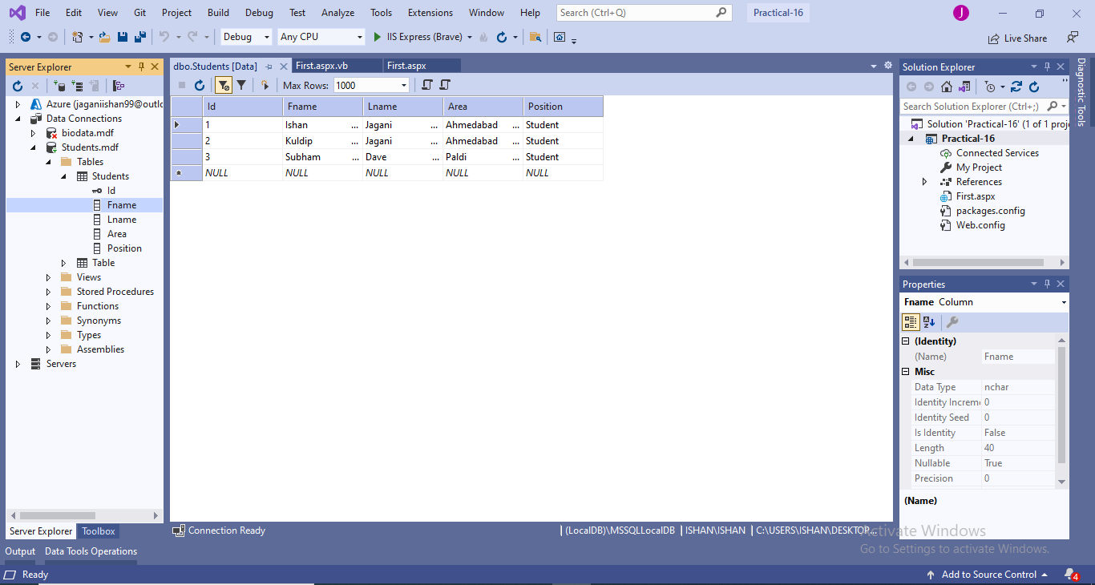

Fetching Data From Database into DropDownList :

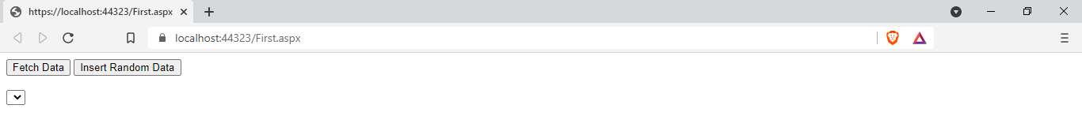

After Fetching :

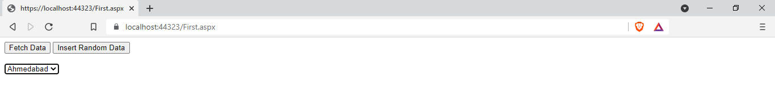

Inserting Data Into Database :

Before Inserting:

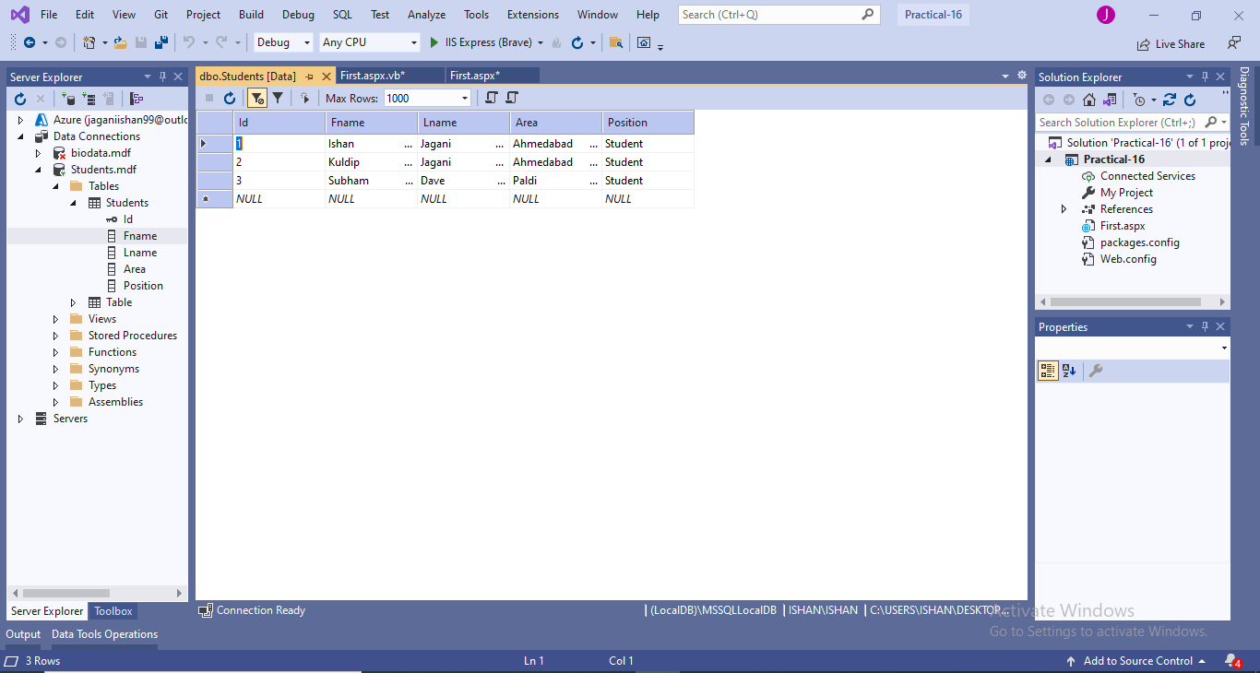

Inserted Data :

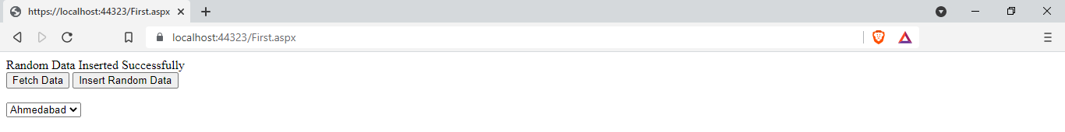

After Inserting Data :

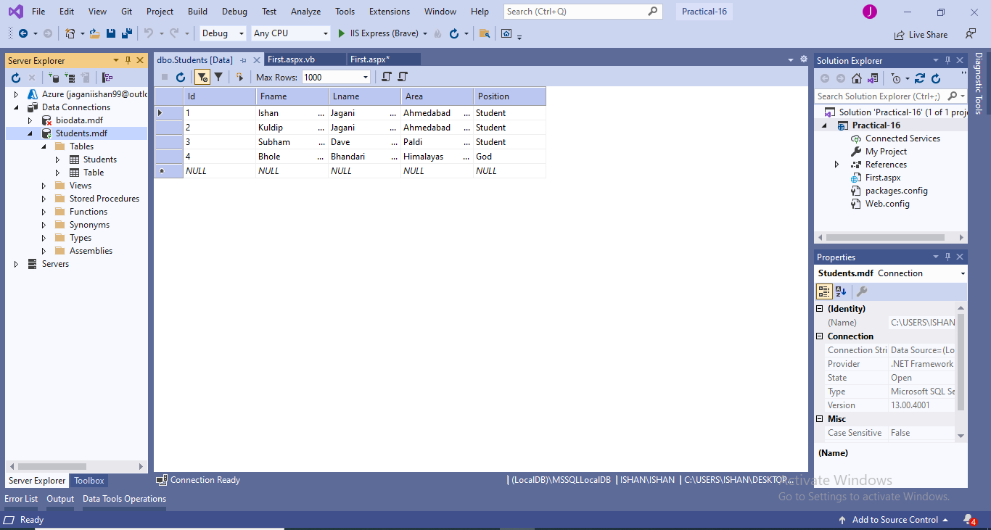

|  |  |  |  |
| --- | --- | --- | --- |
| Start Date | End/Sign Date | Faculty Sign | Remarks/Grade |
|  |  |  |  |